Assignment 1 – System Information and Networking
Organized by 10Alytics Consulting.

Submitted by
Ogochukwu Francisca Kelvin-Nwaigwe
Student ID
GRC-C26-08-EU-007
Submitted to
Odunayo Balogun – 10Alytics Consulting
Date
August 28, 2026

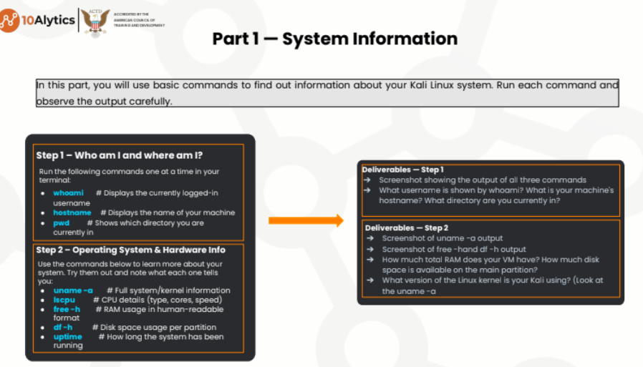

Part 1, Step 1 Solution from Kali Linux
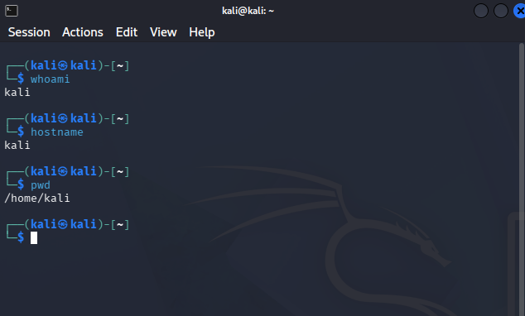

SN | Commands | Meanings | Display from Kali Linux
1 | whoami | Displays the currently logged in user. | Username displayed is kali
2 | hostname | Displays the name of my machine. | My machine hostname is Kali.
3 | pwd | Shows which directory I am currently in. | My current directory is /home/kali

Step 2 Solution
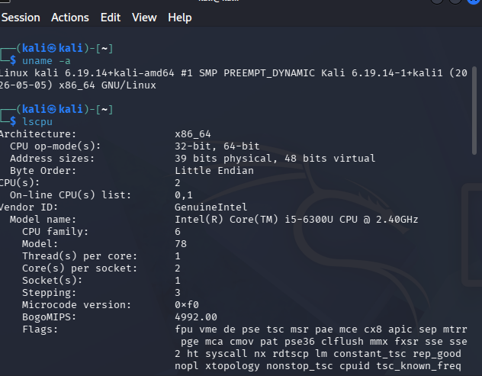

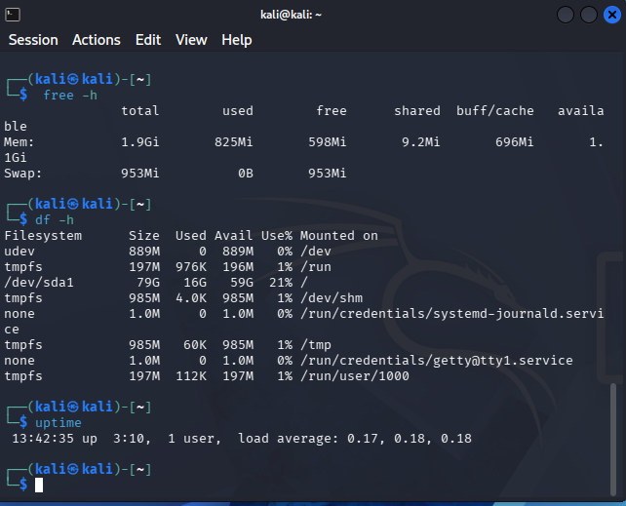

SN | Commands | Meanings | Display from Kali Linux
1 | uname -a | Displays full system/kernel information. | The version of Linus kali is 6.19.14 + kali amd64.
2 | lscpu | Displays the CPU details (type, core, speeds) | Display is on the screenshot.
3 | free -h | Displays RAM usage in human useable format. | Total RAM for my VM is 1.9Gi.
4 | df -h | Displays disc space usage per partition. | Disc space available on the main partition is 889M
5 | uptime | Displays how long the system has been running. | The system has been running for 13:42:35 up.

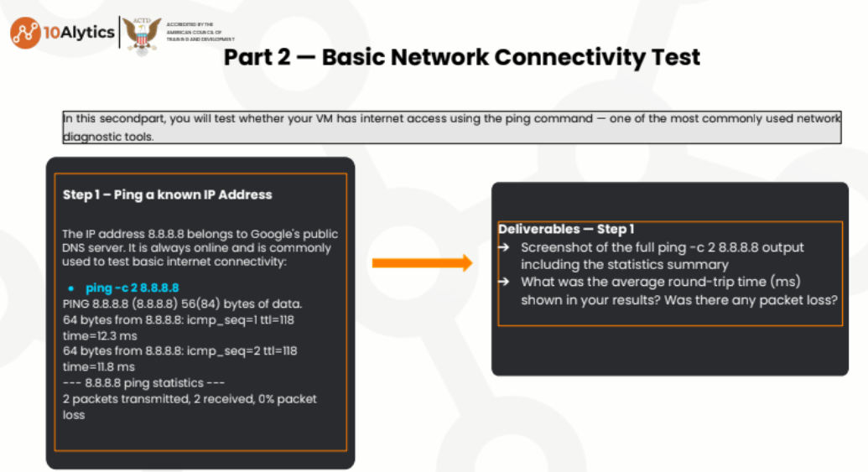

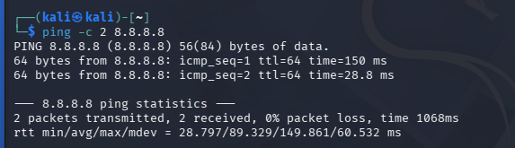

SN | Commands | Meanings | Display from Kali Linux
1 | ping -c 2 8.8.8.8 | It is Google public DNS server used to test basic internet connectivity. | The average round trip time is 89.329ms. There was 0% packet loss.

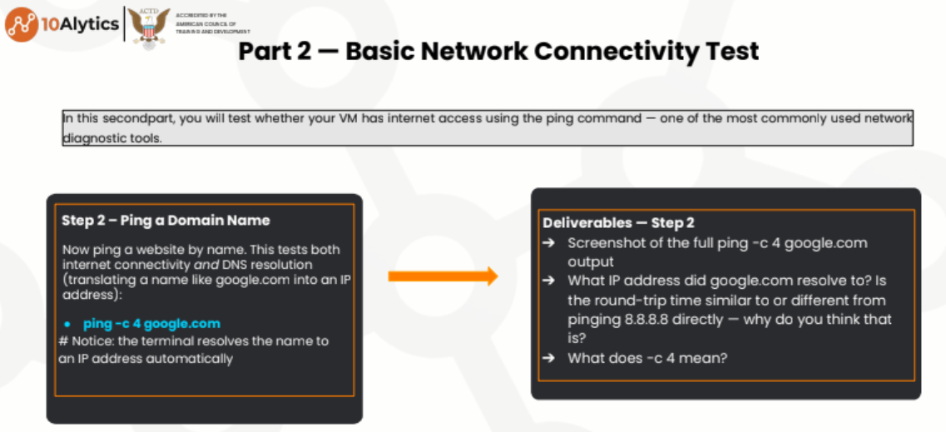

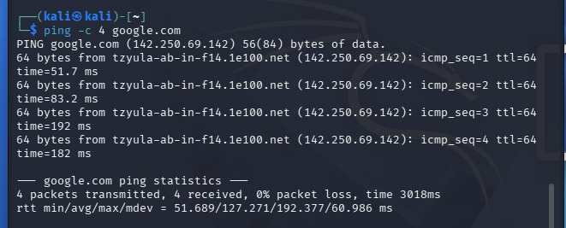

SN | Commands | Meanings | Display from Kali Linux
1 | ping -c 4 goole.com | c4 is used to picture how a system and its groups of networks relate.  c4 tests both internet connectivity and DNS resolution.  It also translates a domain name like google .com into an IP address. | The IP address is 142.250.69.142
 |  |  | The round-trip time is different from pinging 8.8.8.8 (rtt for 8.8.8.8 is 1068ms and rtt for c4 google.com is 3018ms.
 |  |  | Reasons for the difference in the round-trip time(rtt) is basically the DNS overhead from the DNS resolution, any routing, and also average latency calculation from different packet counts.

